**Document-Based Question Essay: The Causes of Secession**

The following question is based on the accompanying documents (A-K) The question is designed to test your ability to work with historical documents. As you analyze the documents, take into account both the source of the document and the author's point of view.

**Instructions:**

Read the documents in Part A and answer the questions after each document. Then read the direction for Part B and write your essay.

**Historical Context:**

By 1861, sectional conflict in the United Sates over slavery and states’ rights escalated to new heights, making further compromise impossible.

**Task:**

**Using information from the documents and your knowledge of United States history, answer the questions the follow each document in Part A. Your answers to the questions will help you write the essay in Part B in which you will fully respond to the prompt below:**

In 1913 historian James Ford Rhodes asserted that the American Civil War can be attributed to a “single cause, slavery.” Assess the validity of his interpretation. What caused the Civil War?

* **Account for the failure of compromise in the United States during the period of 1820 to 1861**
* **Evaluate the importance of slavery as the major cause of Southern secession.**

**Part A**

**Directions: Analyze the documents and answer the question or questions that follow each document ON YOUR ANSWER SHEET. Your answers will help you write the essay.**

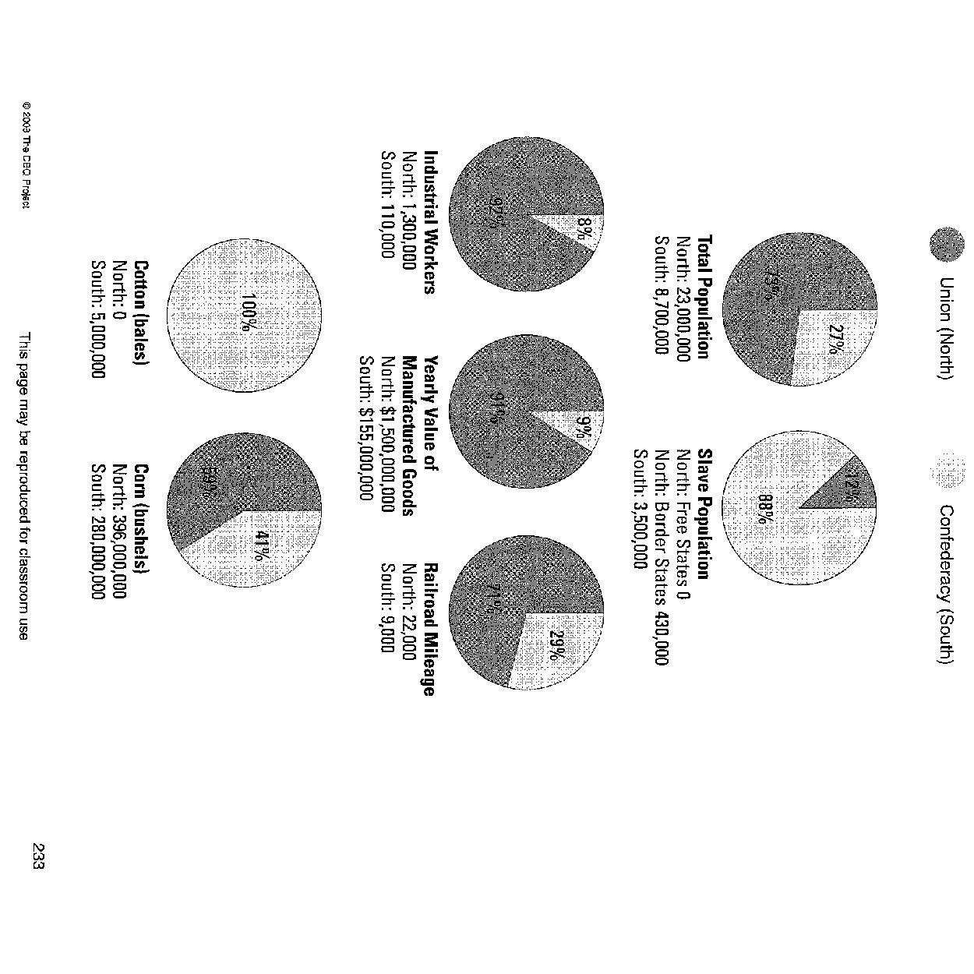

**Document A**

*Comparison of Economies: North vs South*

**Document B**



**Document C**

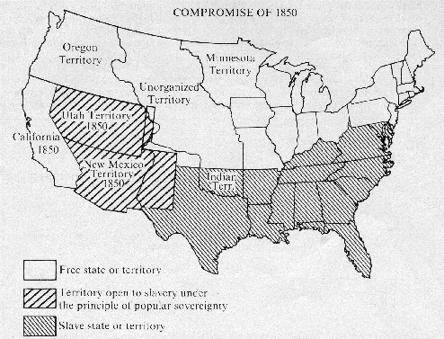

**Document D**

Source: John L. Magee, “Forcing Slavery Down the Throat of a Freesoiler,” 1856

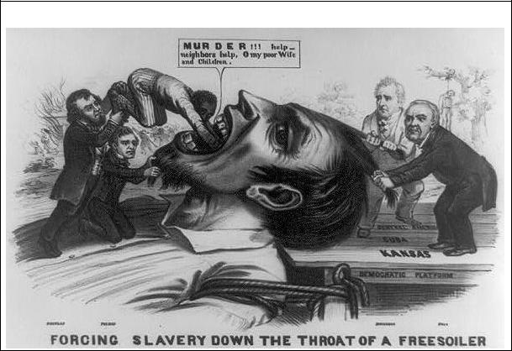

**Document E**

*Excerpt from a speech by Albert Gallatin Brown, a Mississippi politician (September 26, 1860)*

|  |
| --- |
| (The Northerners) hate us now and they teach their children in their schools and churches to hate our children...the John Brown raid...the abolitionists among us tell the tale...The North is accumulating power and it means to use that power to emancipate (free) your slaves...Disunion is a fearful thing but emancipation is worse. Better leave the union in the open face of day  than be lighted from it at midnight by the arsonist's torch." |

**Document F**

**John Brown’s Body**

Old John Brown's body lies a-mouldering in the grave,  
While weep the sons of bondage whom he ventured all to save;  
But though he lost his life in struggling for the slave,  
His truth is marching on.  
  
Chorus:  
G Chorus:  
Glory, Glory, Hallelujah!  
Glory, Glory, Hallelujah!  
Glory, Glory, Hallelujah!  
His soul goes marching on.

John Brown was a hero, undaunted, true and brave;  
Kansas knew his valor when he fought her rights to save;  
And now though the grass grows green above his grave,  
His truth is marching on. …

He captured Harpers Ferry with his nineteen men so few,  
And he frightened "Old Virginny" till she trembled through and through,  
They hung him for a traitor, themselves a traitor crew,  
But his truth is marching on. …

Oh, soldiers of freedom, then strike while strike you may  
The deathblow of oppression in a better time and way;  
For the dawn of old John Brown was brightened into day,  
And his truth is marching on.   
Chorus

**Document G**

*From a speech by William H. Seward, U.S. senator from New York, delivered in Rochester, New York, October 25, 1858:*

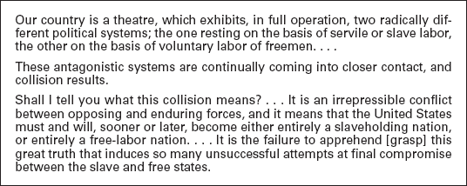

**Document H**

*An April 24, 1851 poster warning the "colored people of Boston" about policemen acting as slave catcher*s.

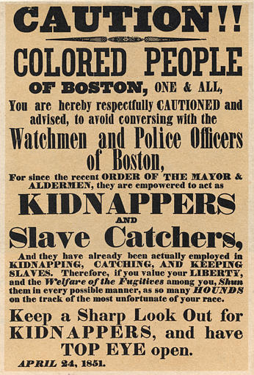

**Document I**

*Excerpt from Supreme Court Chief Justice C.J. Taney, Dred Scott v. Sanford, 1857*

|  |
| --- |
| The rights of private property have been guarded with equal care. Thus the rights of property are united with the rights of person, and placed on the same ground by the fifth amendment to the Constitution… An Act of Congress which deprives a person of the United States of his liberty or property merely because he came himself or brought his property into a particular Territory of the United States, and who had committed no offense against the laws, could hardly be dignified with the name of due process of law…  Upon these considerations, it is the opinion of the court that the Act of Congress the Missouri Compromise which prohibited a citizen from holding and owning property of this kind in the territory of the United States north of the line therein mentioned, is not warranted by the Constitution and is therefore void; and that neither Dred Scott himself, nor any member of his family, were made free by being carried into this territory; even if they had been carried there by the owner, with the intention of becoming a permanent resident… |

**Document J**

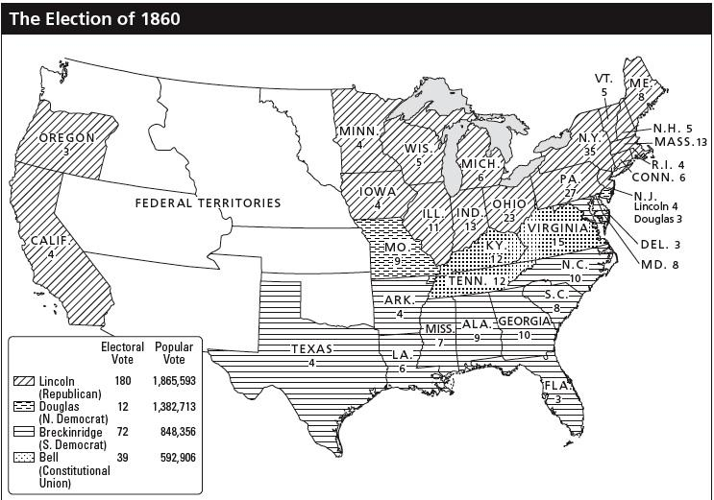

**Document K**

South Carolina ordinance of secession, unanimously approved by the State Legislature on December 20, 1860.

|  |
| --- |
| A geographical line has been drawn across the Union and all the States north of that line have united in the election of a man to the high office of President of the United States whose opinions and purposes are hostile to Slavery. . . . he has declared that that “Government cannot endure permanently half slave  half free” and that the public mind must rest in the belief that Slavery is in the course of ultimate extinction |

**Part B**

**______________________________________________________________________________**

* Write a well-organized essay that includes an introduction, thesis statement, body, and conclusion, as well as body paragraphs with topic sentences, examples from the text, and an explanation of the examples.
* Fully respond to the entire prompt
* Use evidence from the documents to support your answers
* Do not simply repeat the contents of the documents
* Include specific related outside information.